Chapter 5
5.1: Hypothesis Tests Using Normal Distributions
Previously we have looked at 3 different distributions:
- Sampling Distribution: Helped us visualize the behavior of statistics, where each statistic was calculated from a random sample taken from the population.
- Bootstrap Distribution: Helped us estimate the S.E. of the statistic by plotting bootstrap statistics.
- Randomization Distribution: Helped us calculate a p-value, by helping us visualize what statistics look like when the null hypothesis is true.

What did all 3 distributions have in common?
Symmetric and Bell Shaped

In this section, we are going to look at distributions that are symmetric and bell shaped, ie. Normal.
.
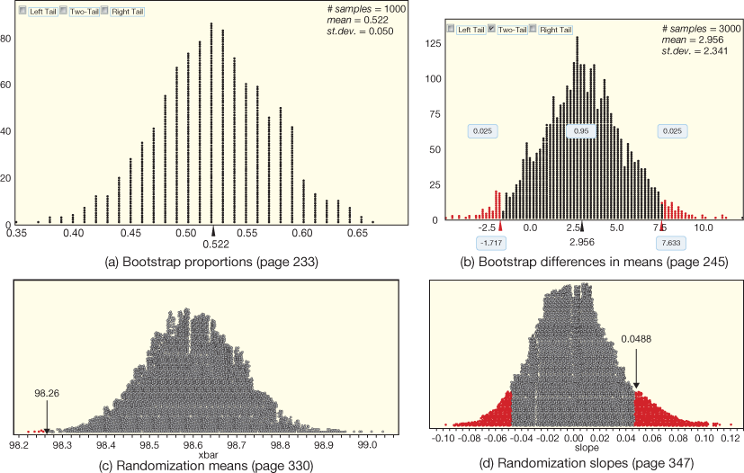
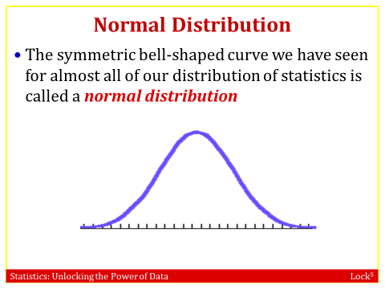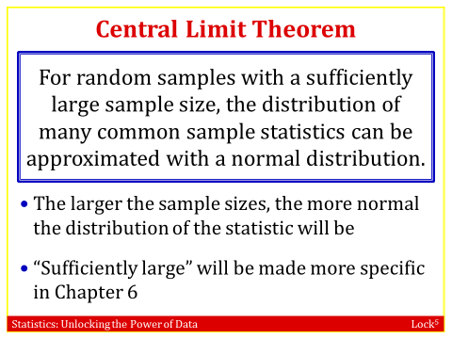
- The normal distribution is the Probability Distribution of a Continuous random variable that has a symmetric, bell-shaped and characterized by its mean µ and standard deviation σ.
- For shorthand we often use the notation N(μ, σ) to specify that a distribution is normal (N) with some mean (μ) and standard deviation (σ).
Figure 5.2 shows how the normal distribution changes as the mean μ is shifted to move the curve horizontally or the standard deviation σ is changed to stretch or shrink the curve.
- 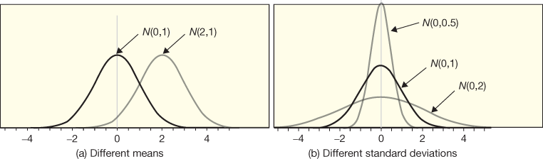 Figure 5.2 Comparing normal curves

The Standard Normal Distribution
Because all the normal distributions look the same except for the horizontal scale, another common way to use normal distributions is to convert everything to one specific standard normal scale. The standard normal, N(0, 1), has a mean of 0 and a standard deviation of 1. We often use the letter Z to denote a standard normal distribution.
To convert from an X value on a N(μ, σ) scale to a Z value on a N(0, 1) scale, we standardize values with the z-score:
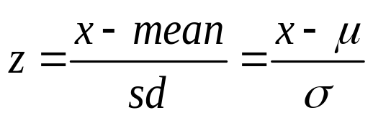
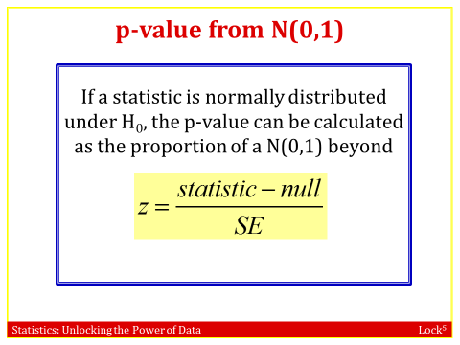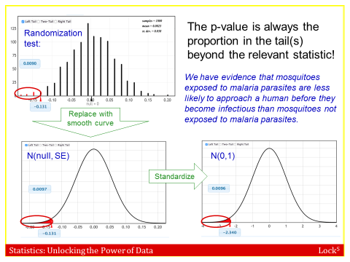

P-value from a Standard Normal Distribution
The p-value for the test is the proportion of a standard normal distribution beyond this standardized test statistic, depending on the direction of the alternative hypothesis.

How to find probabilities using the TI-83(given Z value, find Probability or area under the standard normal curve)
- Press 2nd VARS.
- Select normalcdf(.
- Complete the entry to obtain normalcdf(lower bound, upper bound), substituting the appropriate values in.

Example 1: Find the specified areas for a standard normal distribution, and sketch the area.

- The area to the left of z = –0.8
0.212
- The area to the right of z = 1.2
0.115
Quick Self-Quiz: Standard Normal Distribution
Find the specified areas for a standard normal distribution, and sketch the area.

- The area to the right of z = 2.58
0.0049 ( more than two and half standard deviations above the mean so it is not surprising that it is so small.)
- The area to the left of z = –1.32
0.093
Example 2: Multiple Ways to Find a P-value
Suppose we want to test H₀: p = 0.5 vs H_{a}: p > 0.5 using a sample proportion of 520 out of 1000, or 0.52.

- Use a randomization distribution to find the p-value:
p-value is 0.102 (Answers will vary slightly.)

- What is the standard error from the randomization distribution? ____SE = 0.016 ______
- Model the randomization distribution with a normal distribution with mean 0.5 from the null hypothesis and standard deviation equal to this standard error. Find the p-value by finding the area to the right of 0.52 in this normal distribution.
p-value is 0.106
- Find the standardized test statistic. Then find the p-value by finding the area beyond this standardized value in a standard normal distribution.

z test statistic = Sample statistic – Null parameter = 0.52 – 0.5 = 1.25
SE 0.016

This is a right-tail test and the p-value is 0.106.
- Compare the three p-values!
They will be almost the same (up to round-off error.)

Example 4: Is Divorce Morally Acceptable?
In a study conducted by the Pew Foundation, we learn that 67% of women in a random sample view divorce as morally acceptable. Does this provide evidence that more than 60% of women view divorce as morally acceptable? The standard error for the estimate assuming the null hypothesis is true is 0.021.

- What are the null and alternative hypotheses for this test?
H₀: p = 0.6
H_{a}: p > 0.6
- What is the standardized test statistic?
Sample statistic – Null parameter = 0.67 – 0.6 = 3.333
SE 0.021
- Use the standard normal distribution to find the p-value.
This is a right tail test.
We see that the p-value is 0.00043
- What is the conclusion of the test?
The p-value is very small so we have strong evidence that more than 60% of all women view divorce as morally acceptable.
Example 5: Do Men and Women Differ in Opinions about Divorce?
In the same study described above, we find that 71% of men view divorce as morally acceptable. Use this and the information in the previous example to test whether there is a significant difference between men and women in how they view divorce. The standard error for the difference in proportions under the null hypothesis that the proportions are equal is 0.029.

- What are the null and alternative hypotheses for this test? H₀: p_{M} = p_{F}
H_{a}: p_{M} ≠ p_{F}

- What is the standardized test statistic?
Sample statistic – Null parameter = (0.71-0.67) – 0 = 1.379
SE 0.029
- Use the standard normal distribution to find the p-value. .
This is a two-tail test.
We see that the p-value is 2(0.084) = 0.168
- What is the conclusion of the test?
The p-value is larger than any reasonable significance level, so we do not find evidence of a difference between men and women in the proportion that view divorce as morally acceptable.

5.2: Confidence Intervals Using Normal Distributions
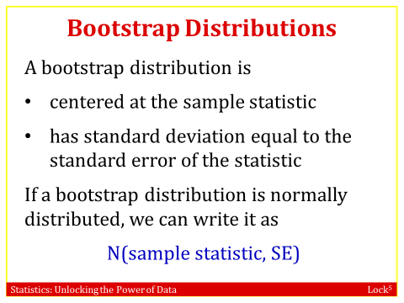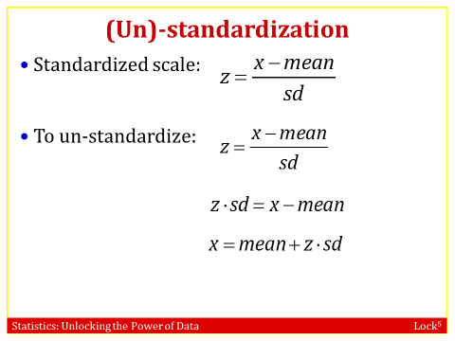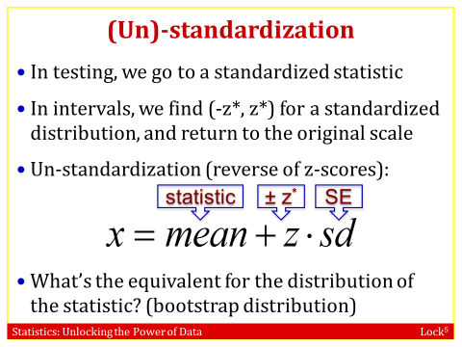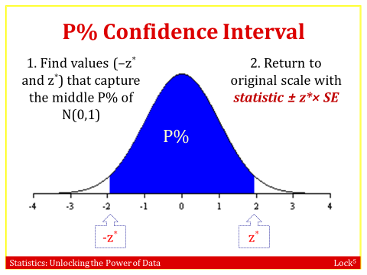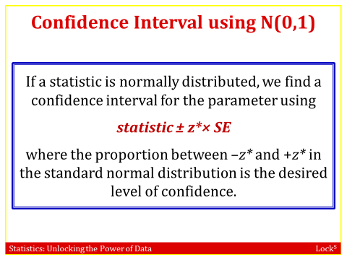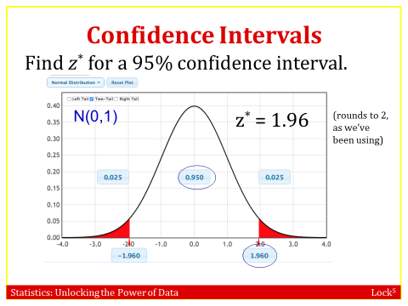
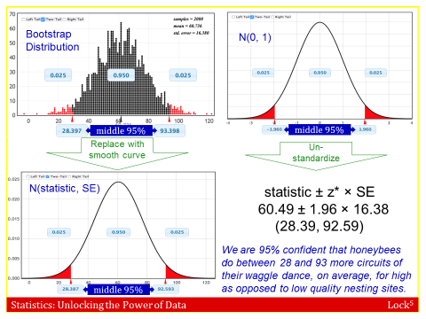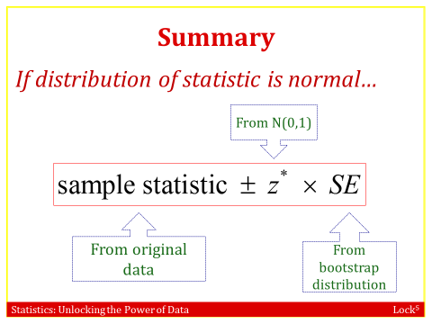
- Why use the standard normal?
- z* is always the same, regardless of the data!
- Common confidence levels:
  - 95%: z* = 1.96 (but 2 is close enough)
  - 90%: z* = 1.645
  - 99%: z* = 2.575
  - 98%: z* = 2.33
Example 1: Find endpoints on a standard normal distribution with the given property, and sketch the area.

- The area between ± z is 0.95.
-1.96 and 1.96
- The area between ± z is 0.80.
-1.28 and 1.28
Quick Self-Quiz: Standard Normal Distribution

Find endpoints on a standard normal distribution with the given property, and sketch the area.

The area between ±Z is 0.90
-1.645 and 1.645
Example 2: Confidence Intervals Three Ways

A survey conducted by the Pew Foundation found that 536 of 908 Twitter users say they use Twitter for get news. We wish to find a 95% confidence interval for the proportion of Twitter users who use it to get news.

What is the sample statistic? 536/908 = 0.590
Use percentiles on a bootstrap distribution to find the 95% confidence interval.
0.559 to 0.621 (Answers may vary slightly)
We can model the bootstrap distribution with a normal distribution with mean equal to the sample statistic and standard deviation equal to the standard error of the bootstrap distribution. Give the mean __0.590_ and standard deviation _0.016__ for this normal distribution. Use percentiles on this normal distribution to find the 95% confidence interval.
0.559 to 0.621

What is z* for a 95% confidence interval? 1.96
Use the formula “Statistic ± z* · SE” to find the 95% confidence interval.
Sample statistic ± z* ⋅ SE
0.590 ± 1.960 (0.016)
0.590 ± 0.031
0.559 to 0.621
Compare the three answers. They are the same (up to minor variations in the simulations).
Example 3: Obesity in America
In Chapter 3, we see that the mean BMI (Body Mass Index) for a large sample of US adults is 27.655. We are told that the standard error for this estimate is 0.009. If we use the normal distribution to find a 99% confidence interval for the mean BMI of US adults:

- What is z*? 2.575
- Find and interpret the 99% confidence interval.
Sample statistic ± z* ⋅ SE
27.655 ± 2.575(0.009)
27.632 to 27.678
We are 99% confident that the mean BMI of all US adults is between 27.632 and 27.678.
Example 4: Obesity in America: Exercises vs Non-exercisers
Also in Chapter 3, we see that the difference in mean BMI between non-exercisers (those who said they had not exercised at all in the last 30 days) and exercisers (who said they had exercised at least once in the last 30 days) is , with a standard error for the estimate of SE = 0.016. If we use the normal distribution to find a 90% confidence interval for the difference in mean BMI between the two groups:

- What is z*? 1.645
- Find and interpret the 90% confidence interval.
Sample statistic ± z* ⋅ SE
1.915 ± 1.645(0.016)
1.889 to 1.941
We are 90% confident that the mean BMI of non-exercisers is between 1.889 and 1.941 higher than the mean BMI of exercisers, among all US adults.

